**AWS Task-4**

**Task Description:**

Launch an EC2 instance (Linux and Windows) along with a web server. Then, create an EBS volume of 5 GB, attach it to an EC2 machine (Linux and Windows), and take a snapshot. Finally, create an EBS volume using the taken snapshot.

===========================================================

1. **Launching EC2 Instance – Windows Part: -**
   1. Login to AWS Console using my AWS login credentials.
   2. Creating a instance by using “**Launch Instances**” option.

**Go to EC2 -> Instances ->** Click **Launch instances** (shown below)

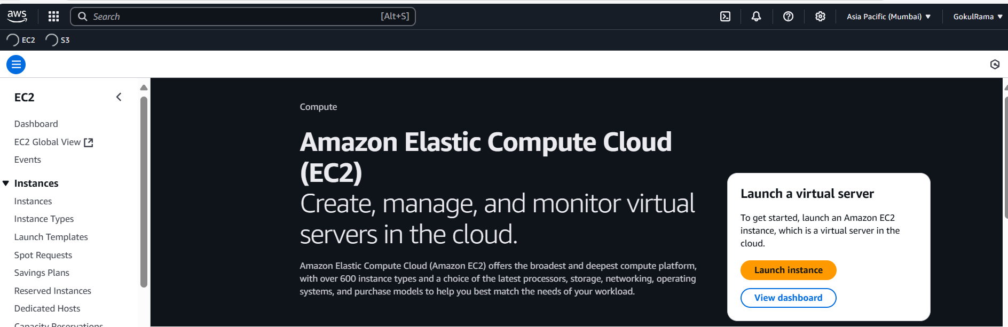

* 1. Once clicked “Launch Instances” and do the below configurations for VM that you want to create.

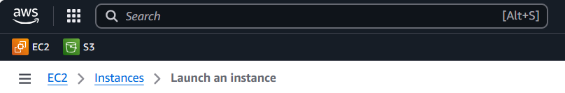

* 1. In Name section -> Give EC2 VM name as “**EC2-Windows**”.

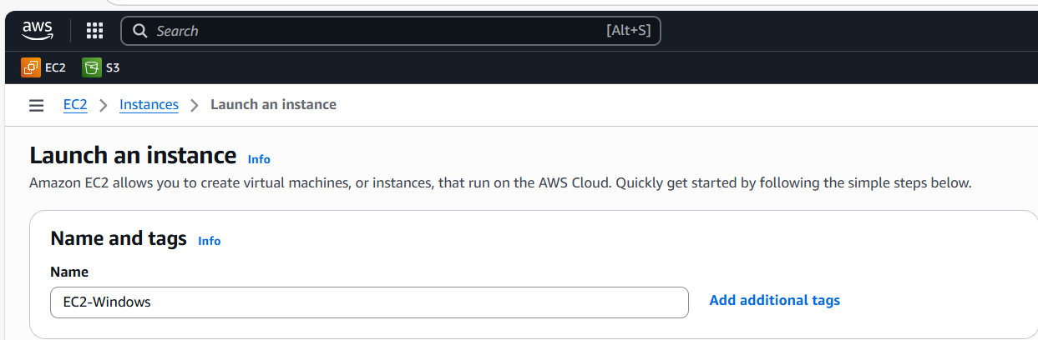

* 1. Choose AMI (i.e) OS -> Select “**Windows”**

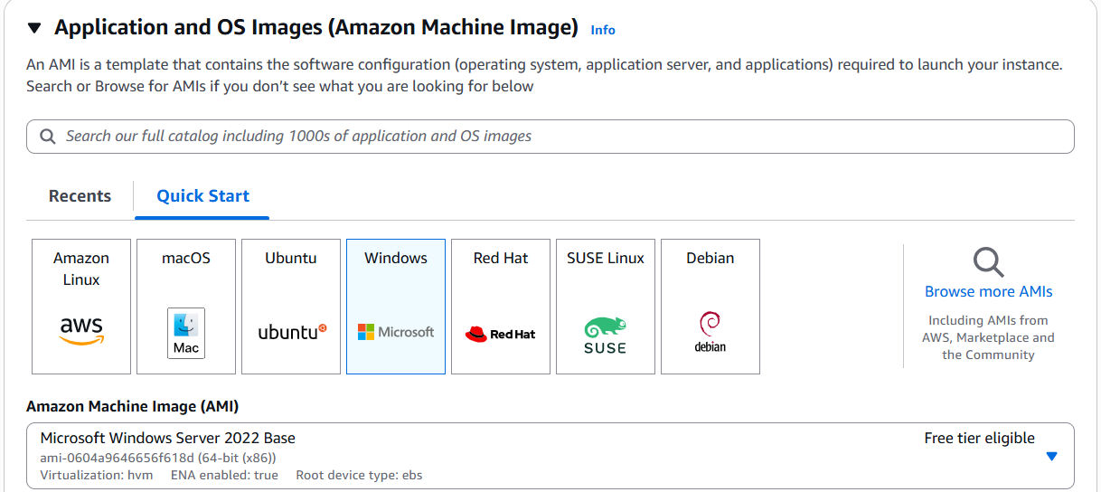

* 1. Select OS Version for Windows and it should be Free tier eligible is

**“** **Microsoft Windows Server 2022 Base “**.

Select Instance and it should be Free tier eligible is **“** **t2.micro “**

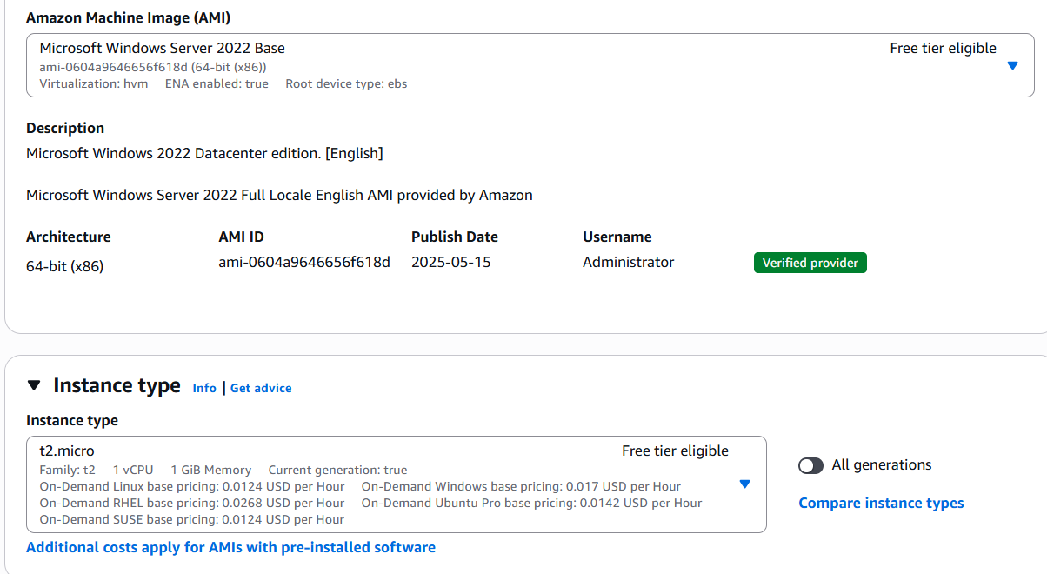

* 1. For SSH Authentication – Select the already generated **key pair is “ubuntu-test”**

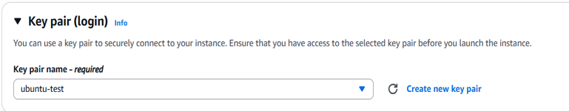

* 1. In the Network settings for windows: “Choose default option”

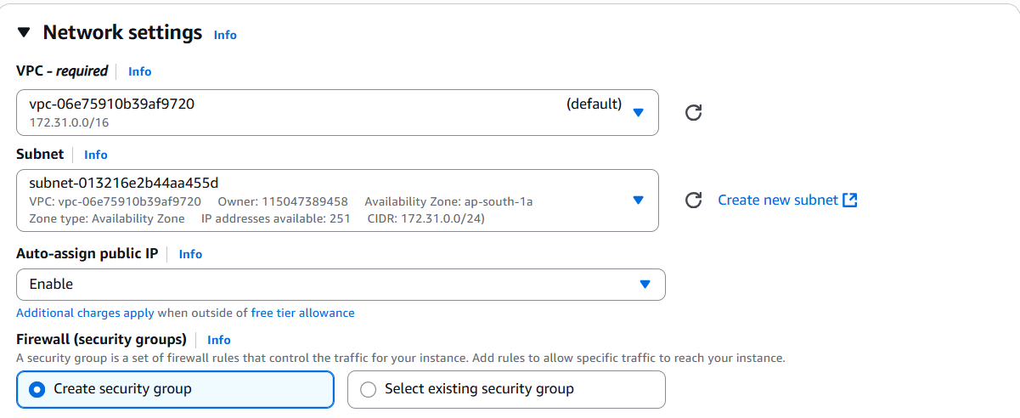

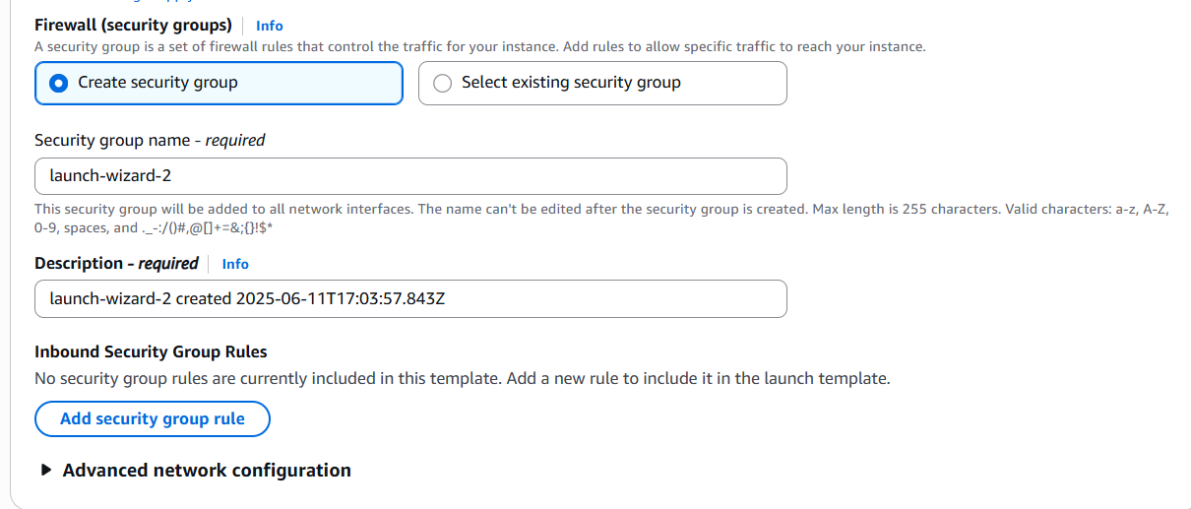

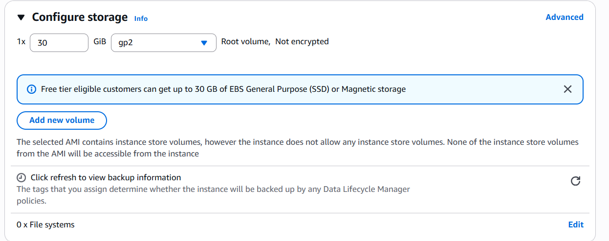

1.9 Click **Launch Instance**

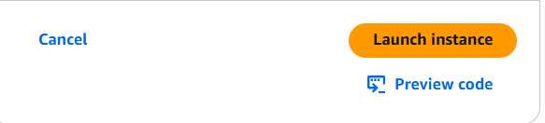

* 1. Once instance has been launched for windows look like below and instance

state seems like “ **Running** ”

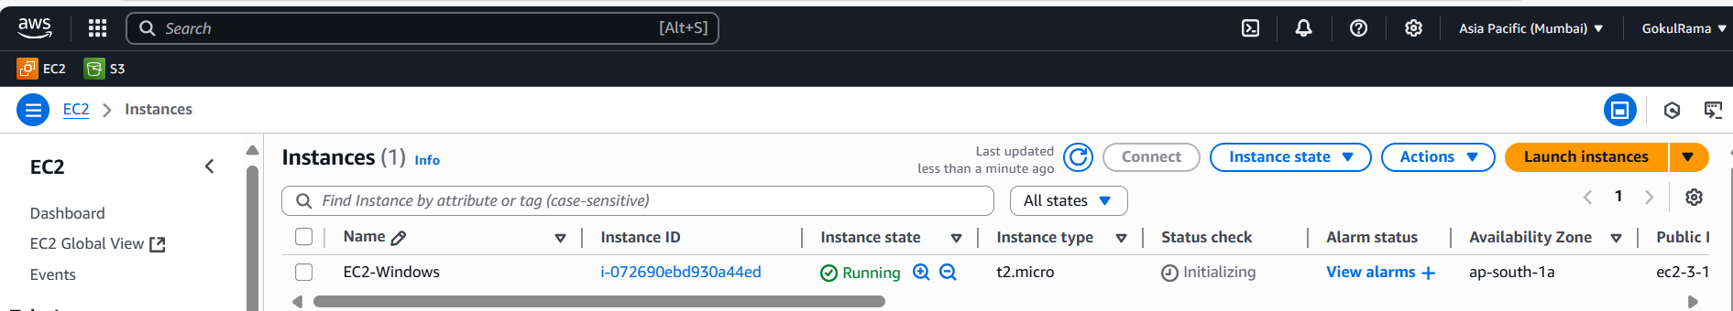

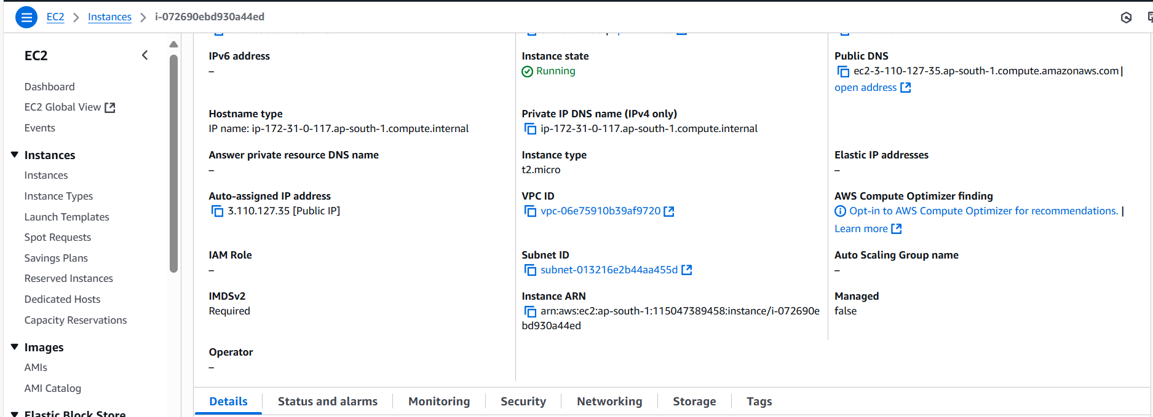

* 1. Select respective **EC2 instance** -> Go to **Security ->** Choose corresponding **security groups.**

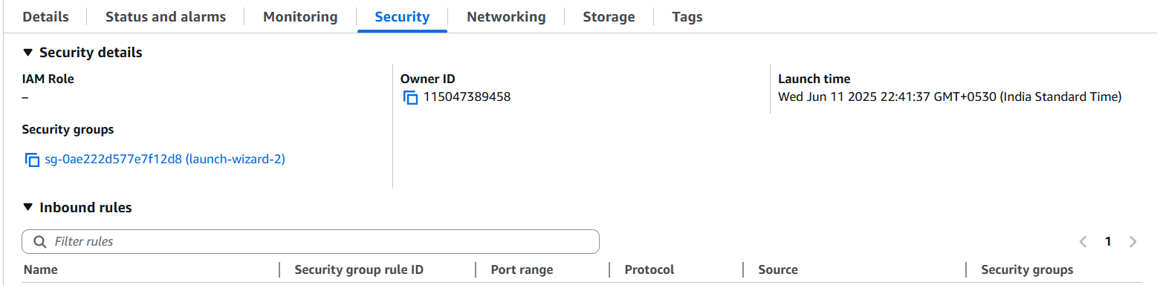

1.11 In the **respective security group** -> Click **Edit Inbound Rules**

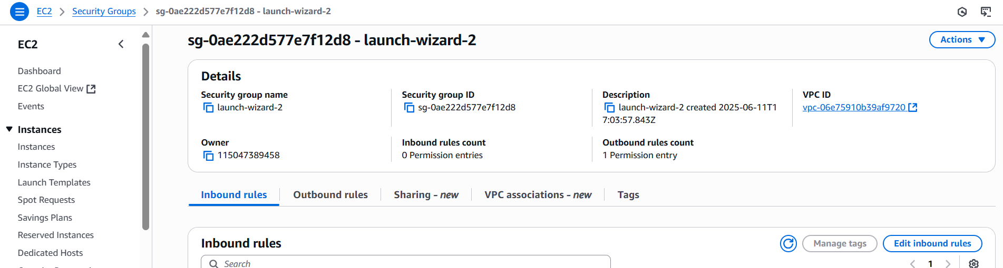

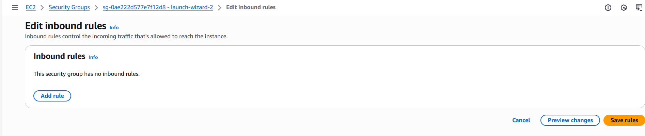

* 1. Add the **inbound rule (Incoming traffic) ->** For **windows** (Add RDP port and port range is 3389 and allow traffic from anywhere from the internet) **-> Click Save Changes**

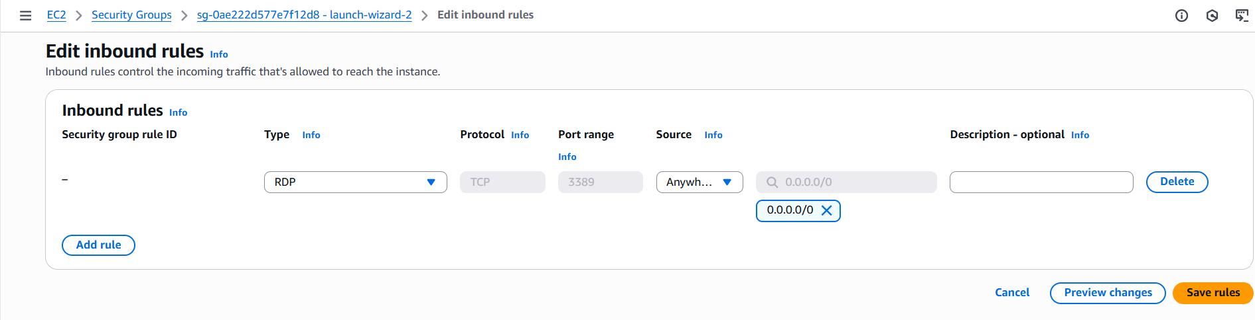

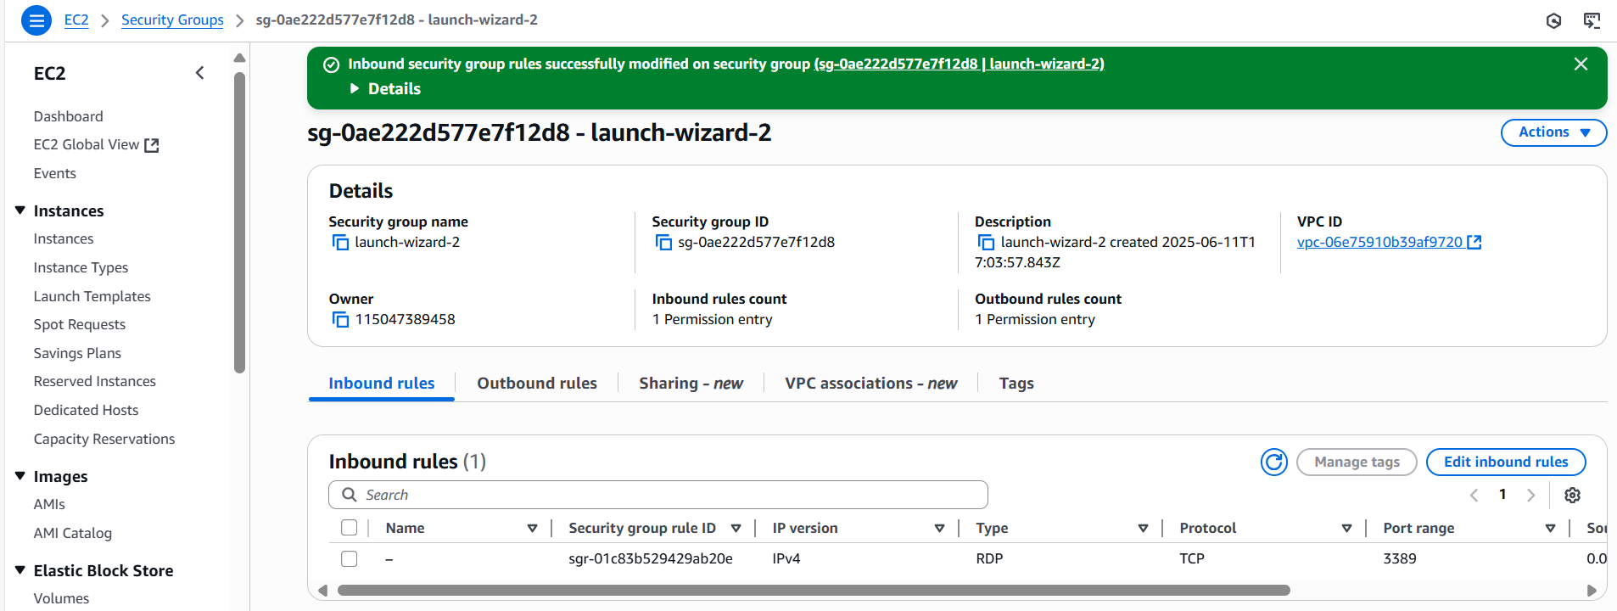

* 1. **Stop the EC2 instance** by using **Stop instance option under Instance state**.

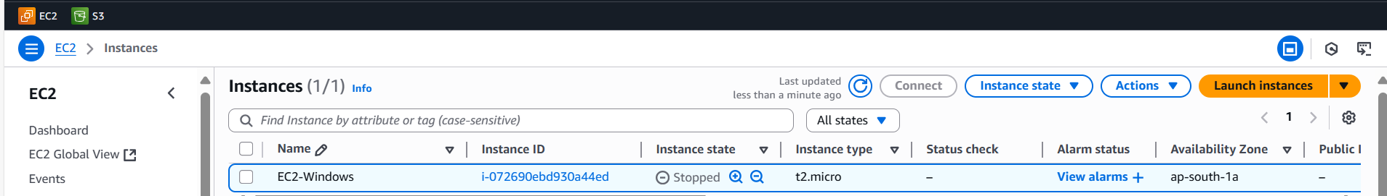

1. **Creating EBS Volume: -**

**2.1** Go to **Elastic Block Store ->** Select **Volumes.**

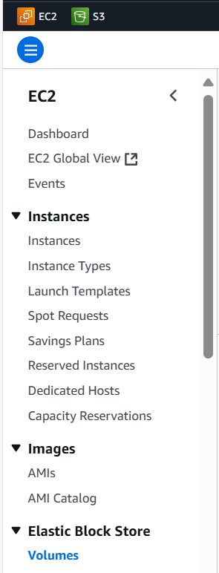

* 1. Click **Create Volume**

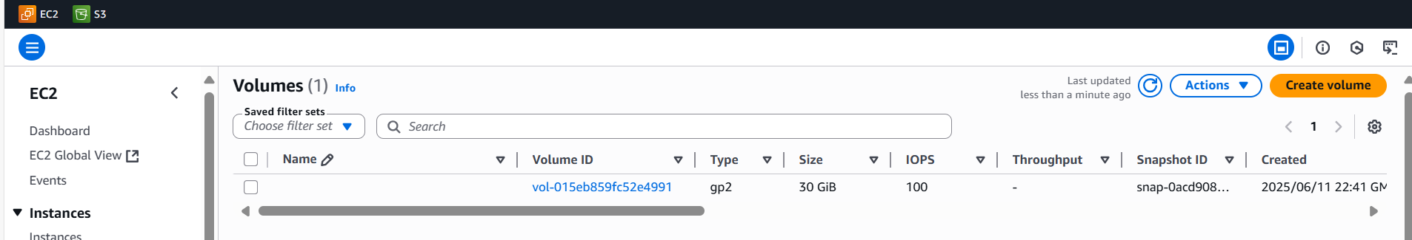

* 1. Once **Created Volume looks like below,**



* 1. **In Create Volume,**
* Choose **Volume type -> General Purpose SSD (gp3).**
* **Size – 5 GiB.**
* Choose **Availability Zone – ap-south-1a (Note – Availability Zone of EBS and EC2 instance should be same only).**
* **Remaining option should be default only.**
* Click **Create Volume.**

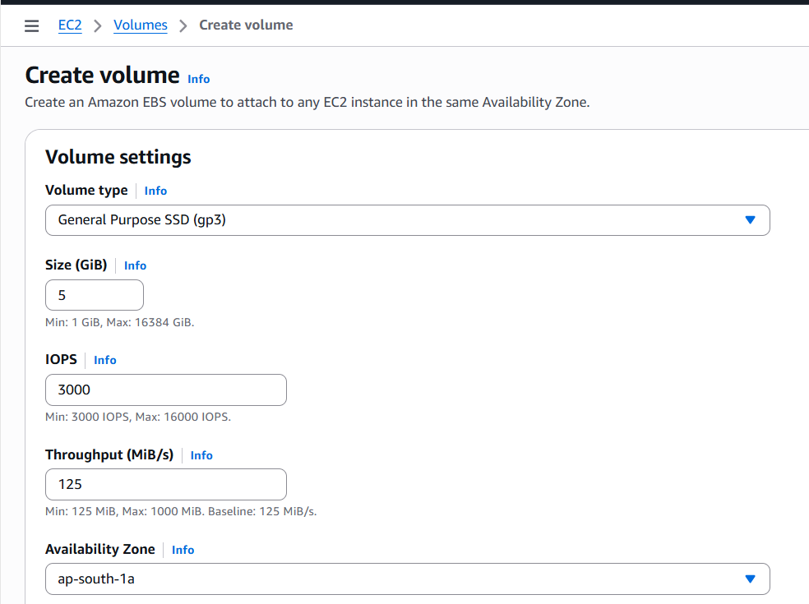

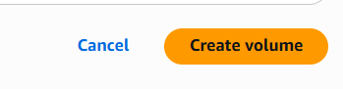

* 1. Now the **New Volume has been created** for **5 GB.**

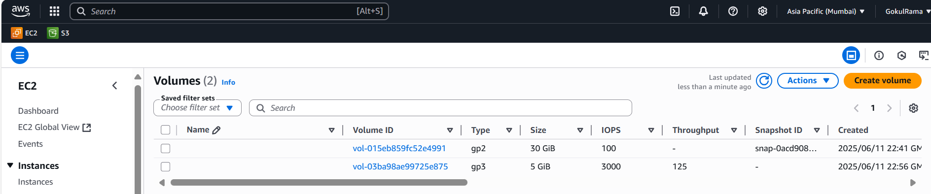

* 1. Renamed **the New Volume is EC2-Windows-NewVolume.**

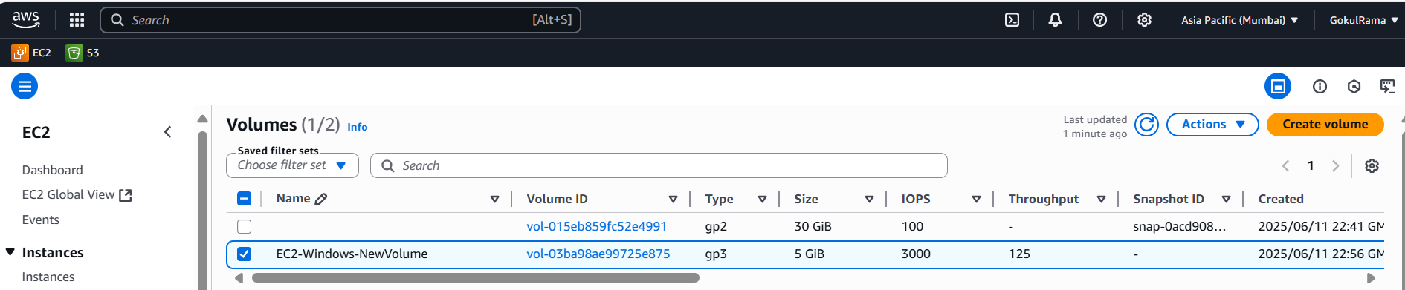

* 1. **Attach the New Volume (EC2-Windows-NewVolume) to EC2 instance by using Attach Volume option [ Actions -> Attach volume]**

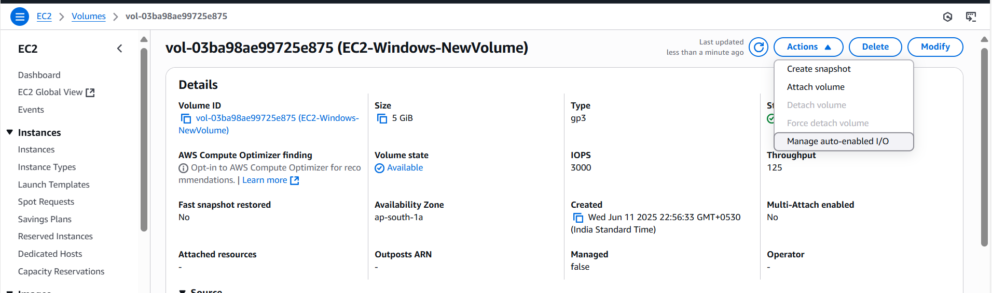

* 1. **Attach Volume configuration is,**
* Select **Instance** – Choose **respective EC2 instance.**
* **Device name** – Choose **xvdb** (any device names its optional)
* Click **Attach volume.**

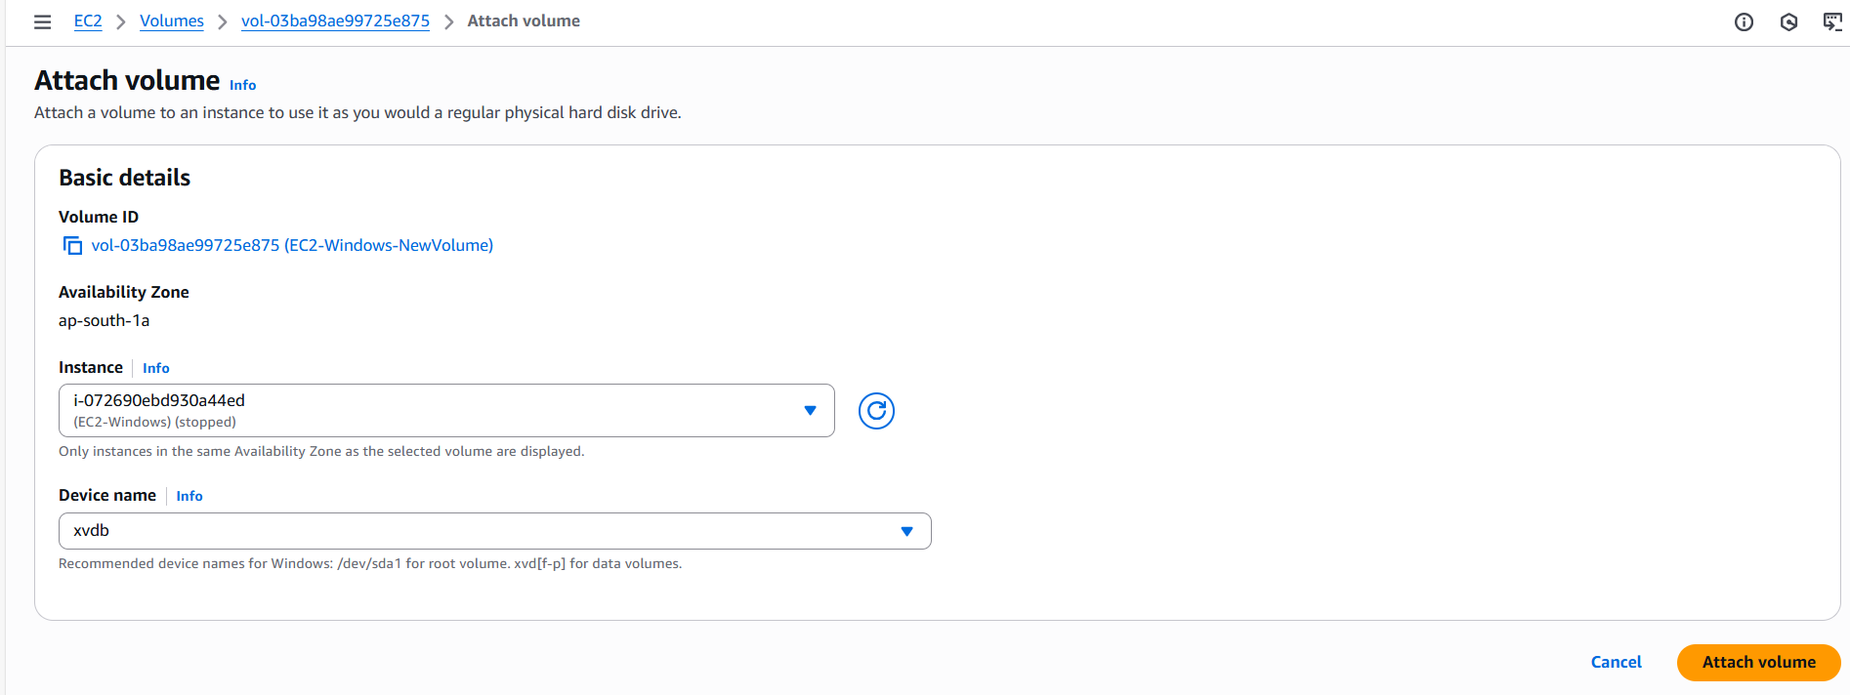

* 1. Once the **New Volume has been attached to EC2 instance -> Go back to EC2 instance screen -> Open respective EC2 instance -> Goto Storage -> See the New Volume [xvdb] is available in EC2 instance.**

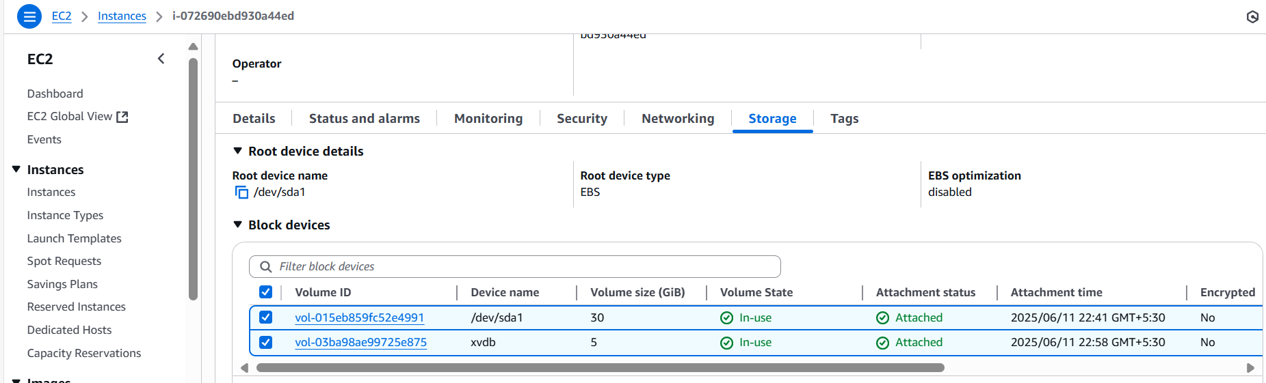

* 1. Select respective **EC2 instance (EC2-Windows)** -> Go to **instance state** ->

select **Start instance**.

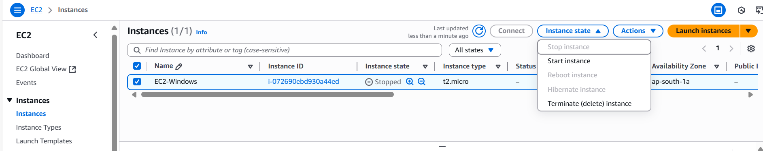

* 1. Once instance has been launched for windows look like below and instance state seems like “**Running**”.

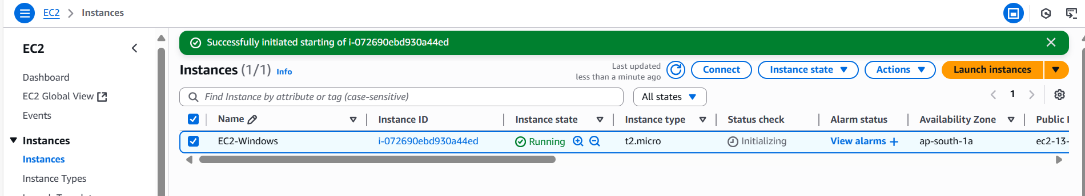

* 1. Click “Connect**”** option and do “RDP **Client**” configurations for windows -> Go

to “RDP Client”.

Click “ **Get Password** ” option

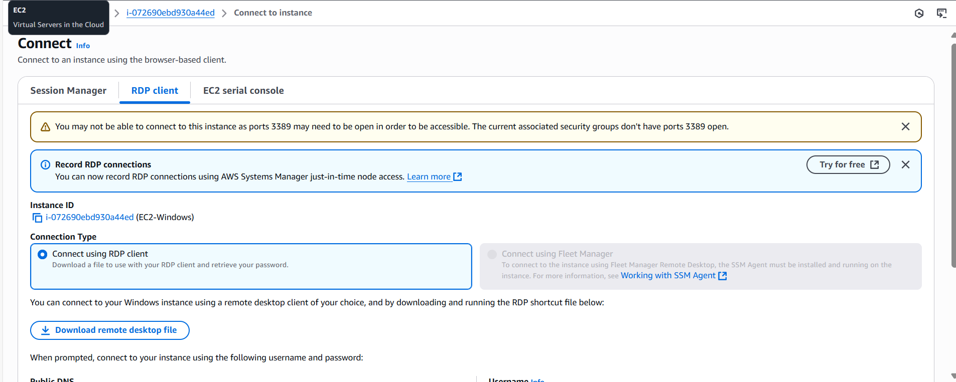

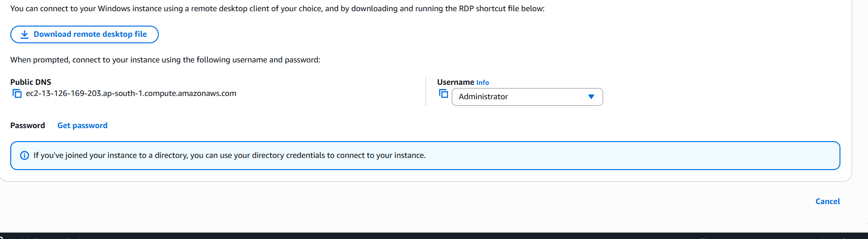

* 1. Choose the respective “Private Key” file that we downloaded for respective “

Public key” and click “Decrypt password “.

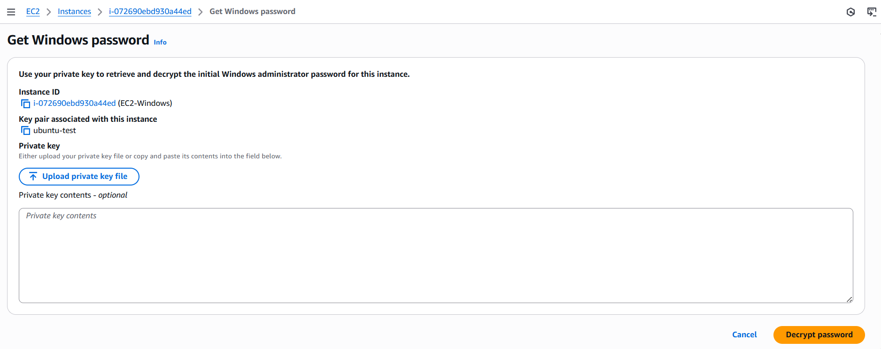

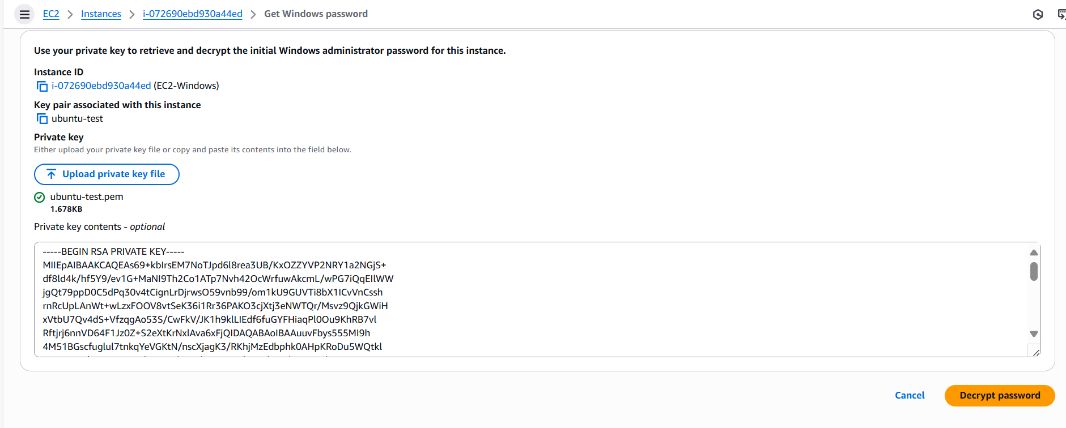

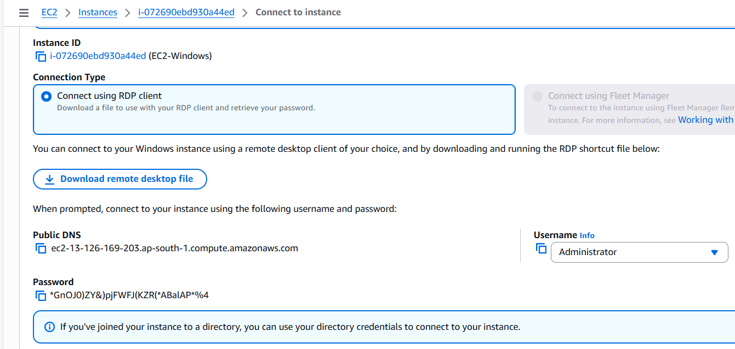

* 1. Go to my local machine -> Go to Run -> Type mstsc (For RDP).

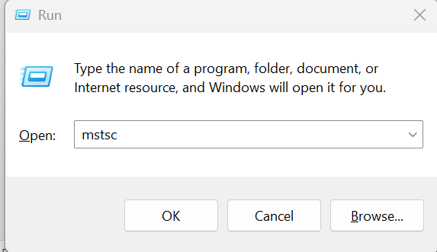

**RDP will appear,**

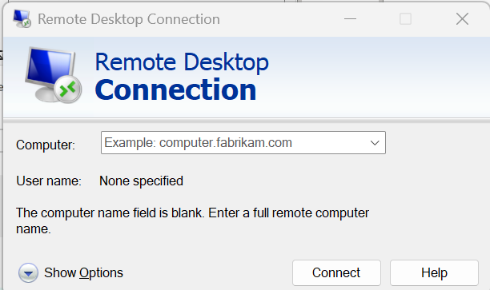

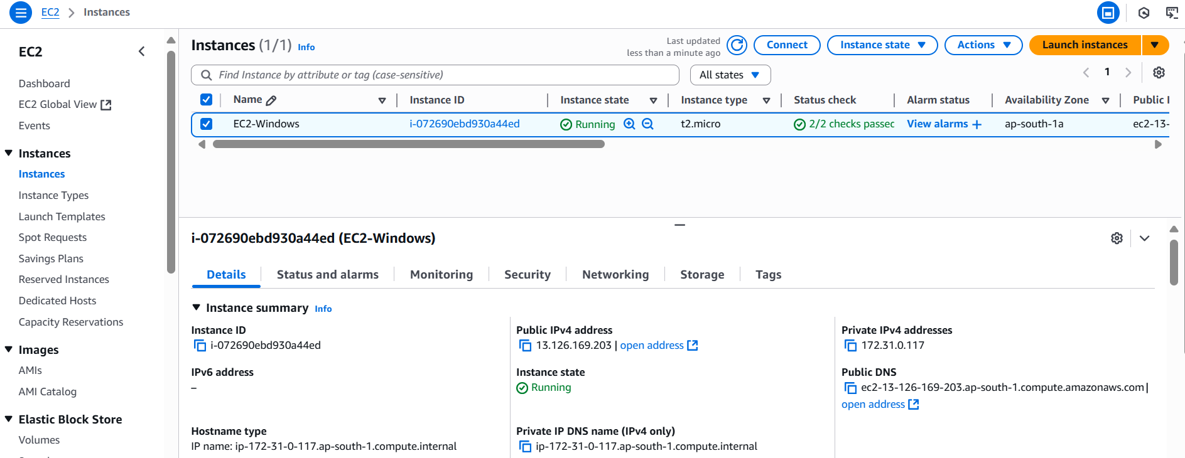

* 1. Enter “Public IP “of respective VM and enter username (Windows) as “

Administrator “

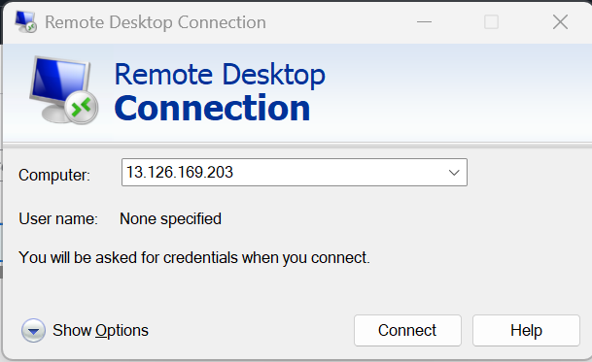

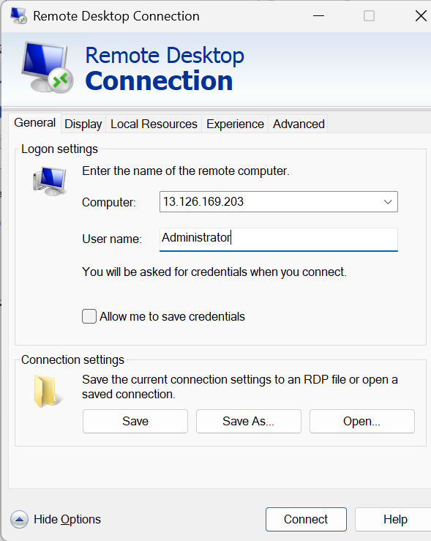

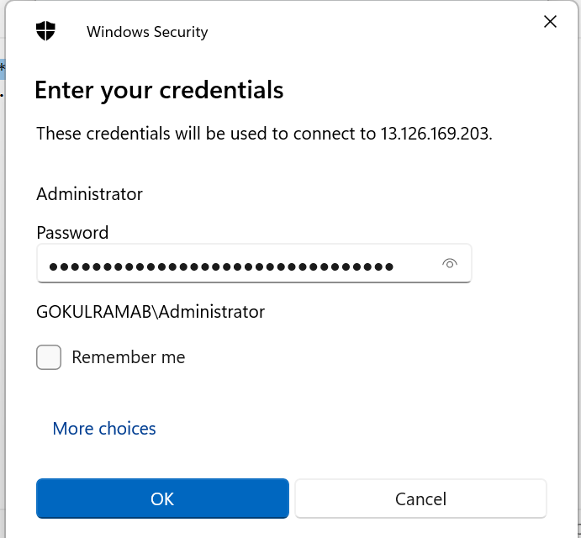

* 1. Once entered **RDP credentials**, we **authenticated to windows VM** look like below,

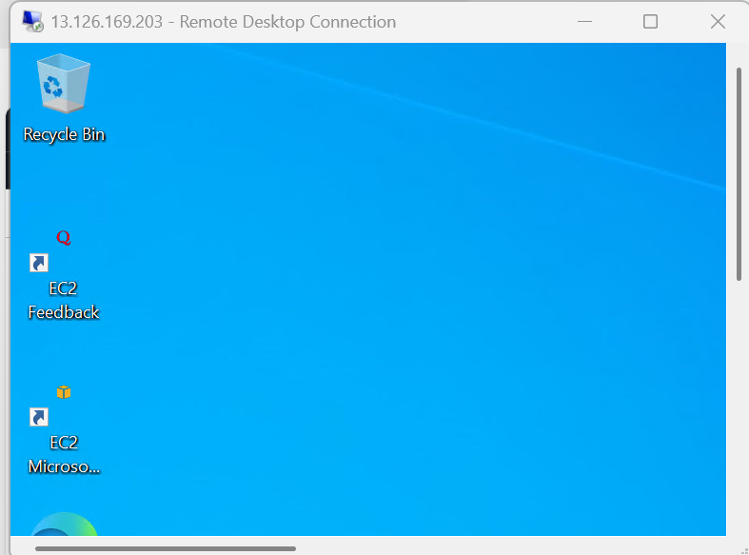

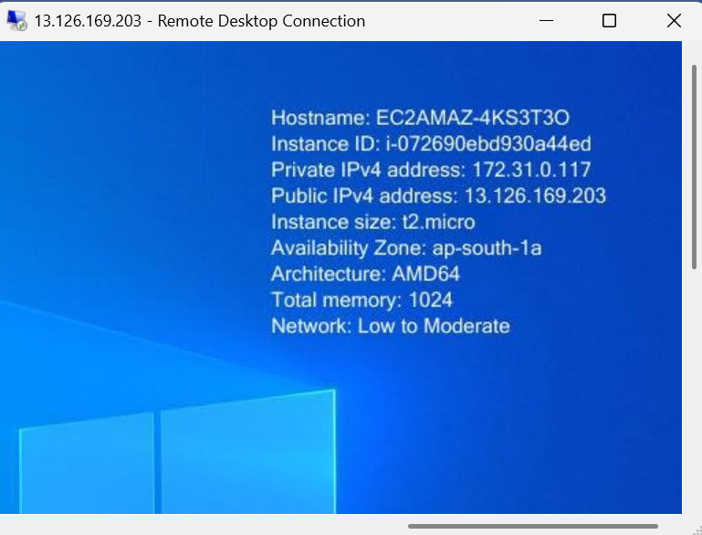

* 1. Once logged in, open **Disk Management** (Press Windows+R key -> Type diskmgmt.msc, and press Enter).

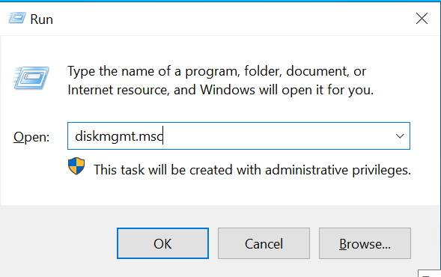

* 1. Now see the **new volume** listed as "**Disk 1**".

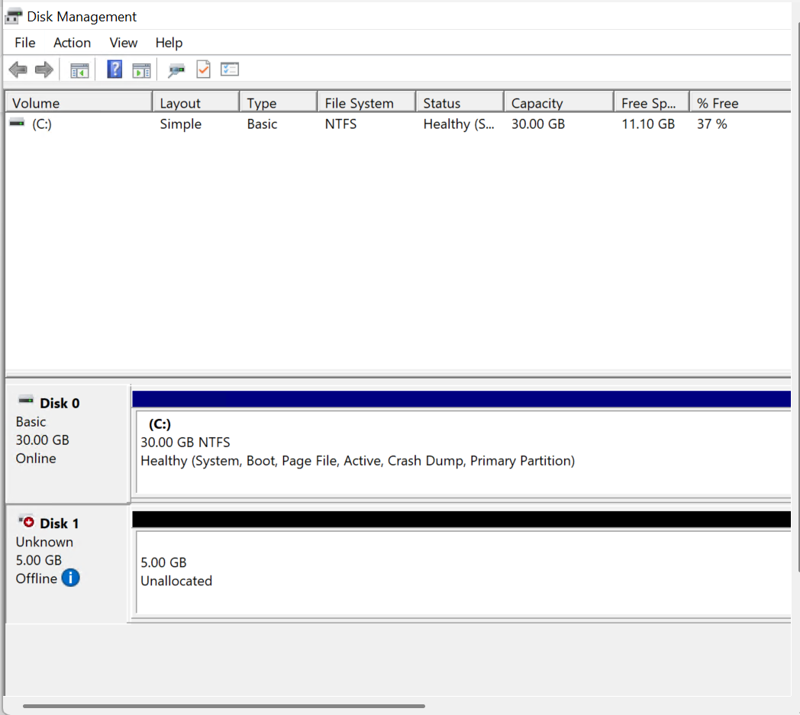

* 1. **Right-click on the new disk and select "Online".**

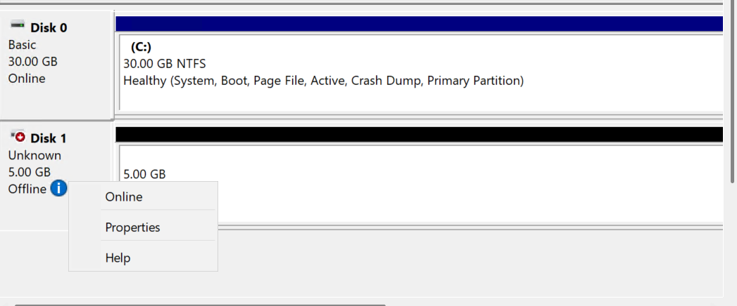

* 1. **Right-click again and select "Initialize Disk".**

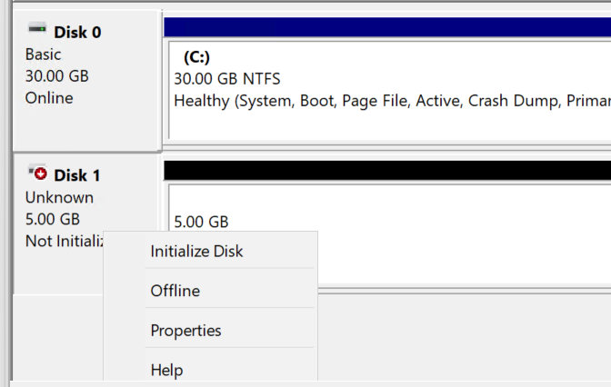

* 1. Choose the partition style (MBR).

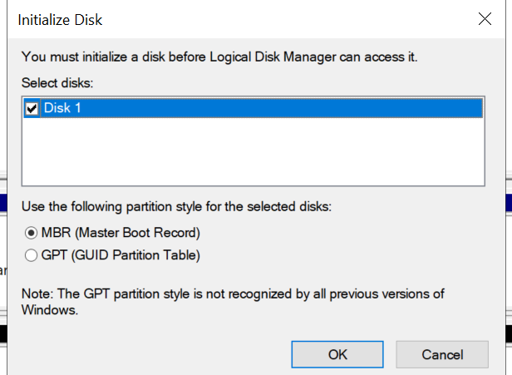

* 1. **Right-click on the unallocated space and select "New Simple Volume".**

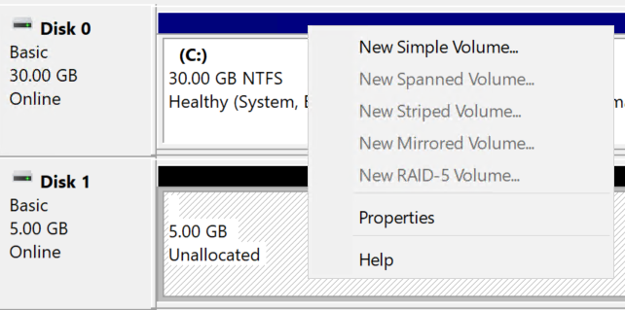

* 1. **Instructions to create the partition: -**
* Click Next

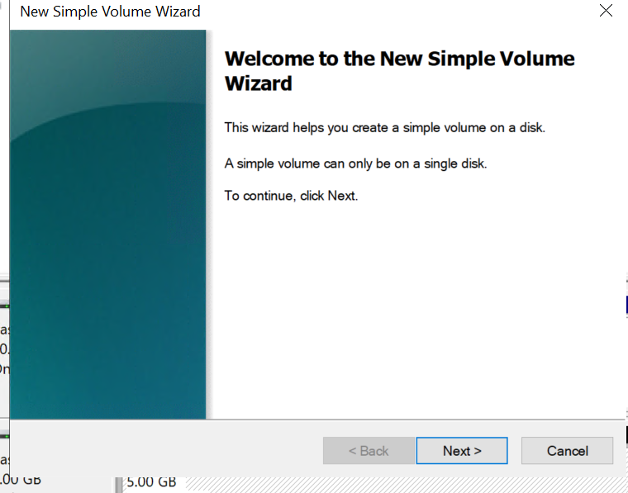

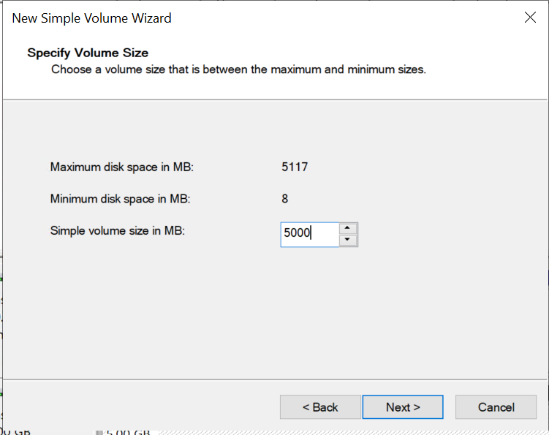

* Choose **Drive Letter: D**

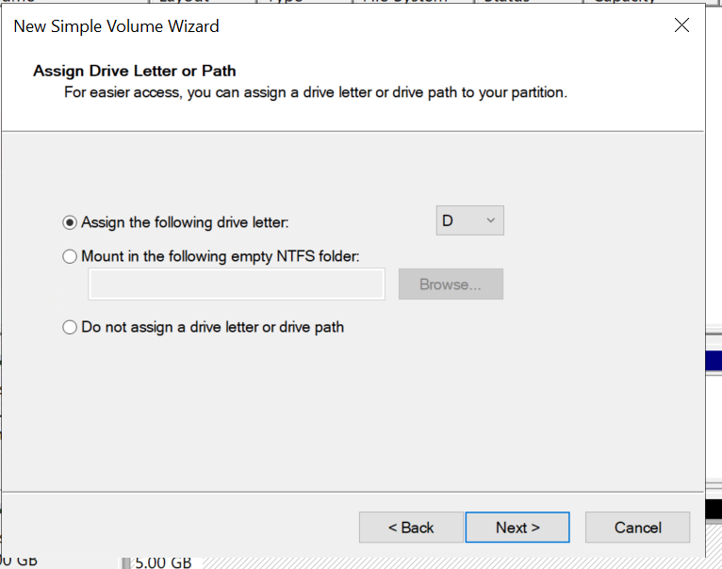

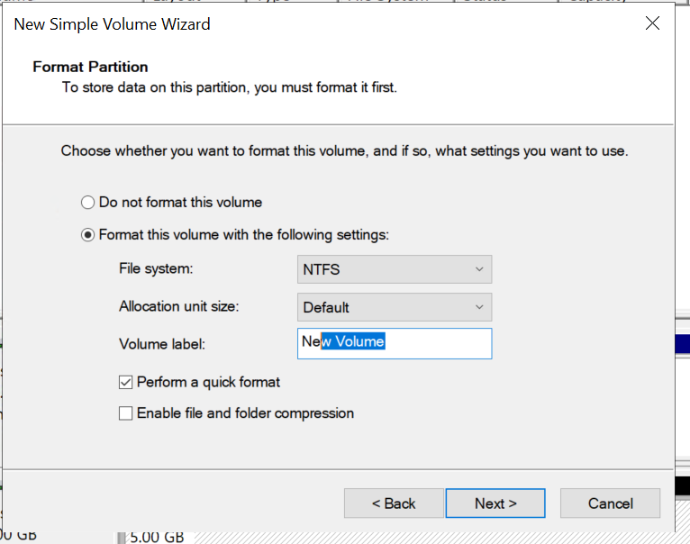

* Click **Finish**

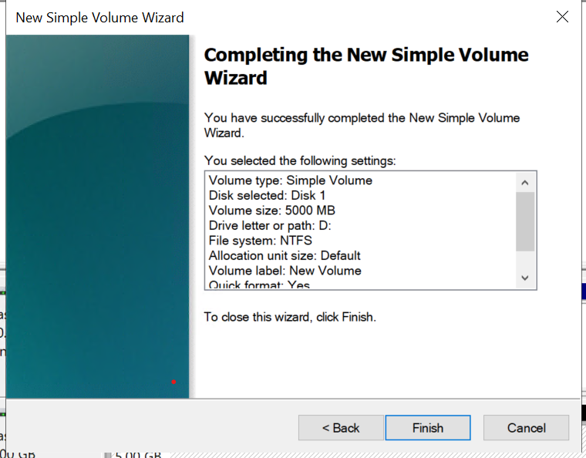

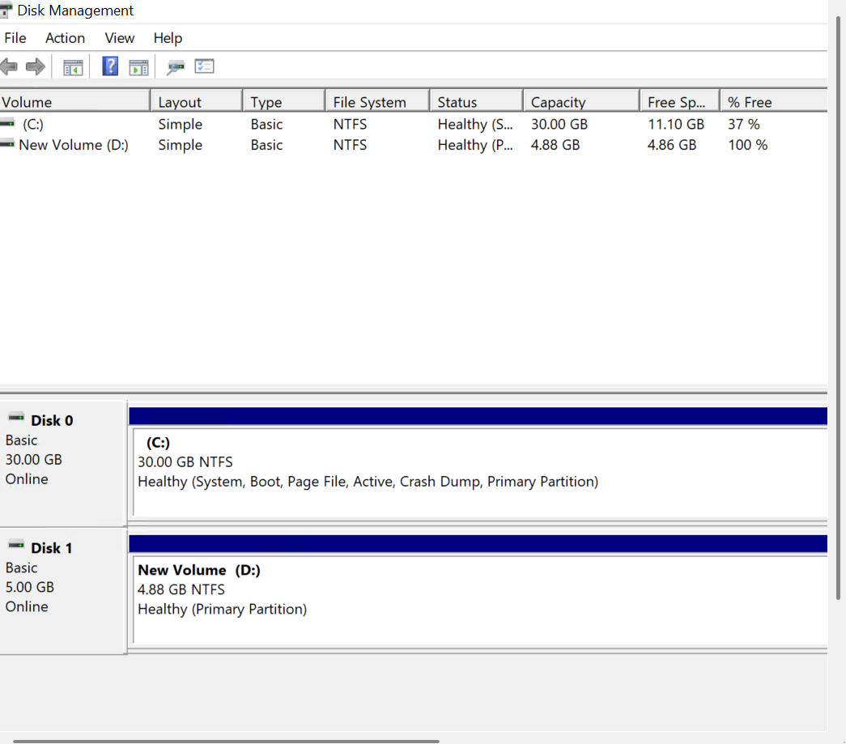

* Now **able to access the EBS volume within the Windows EC2 instance** as a **New Volume (D:)**

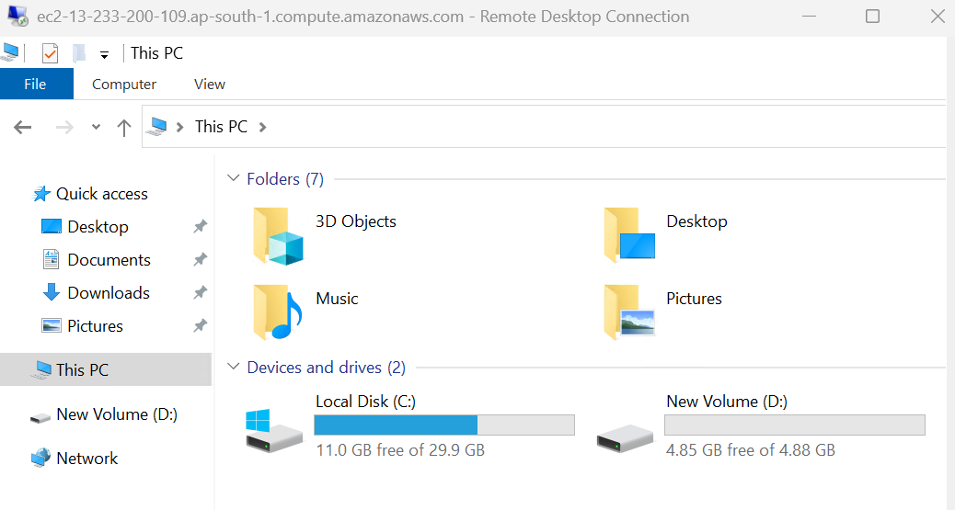

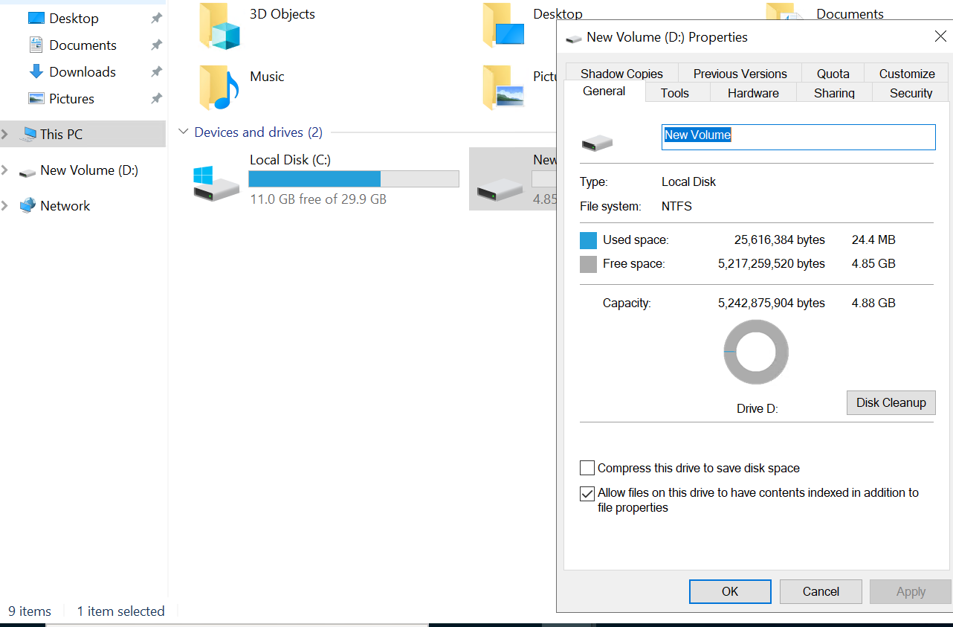

1. **Launching EC2 Windows Instance along with Webserver: -**

In order to enable IIS, launch Server Manager and select Manage > Add Roles and Feature

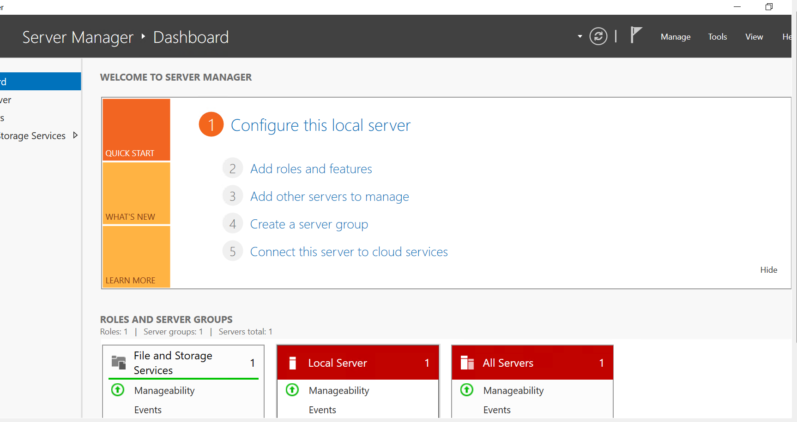

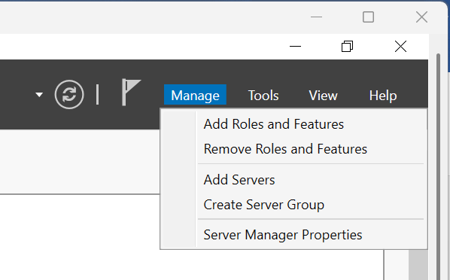

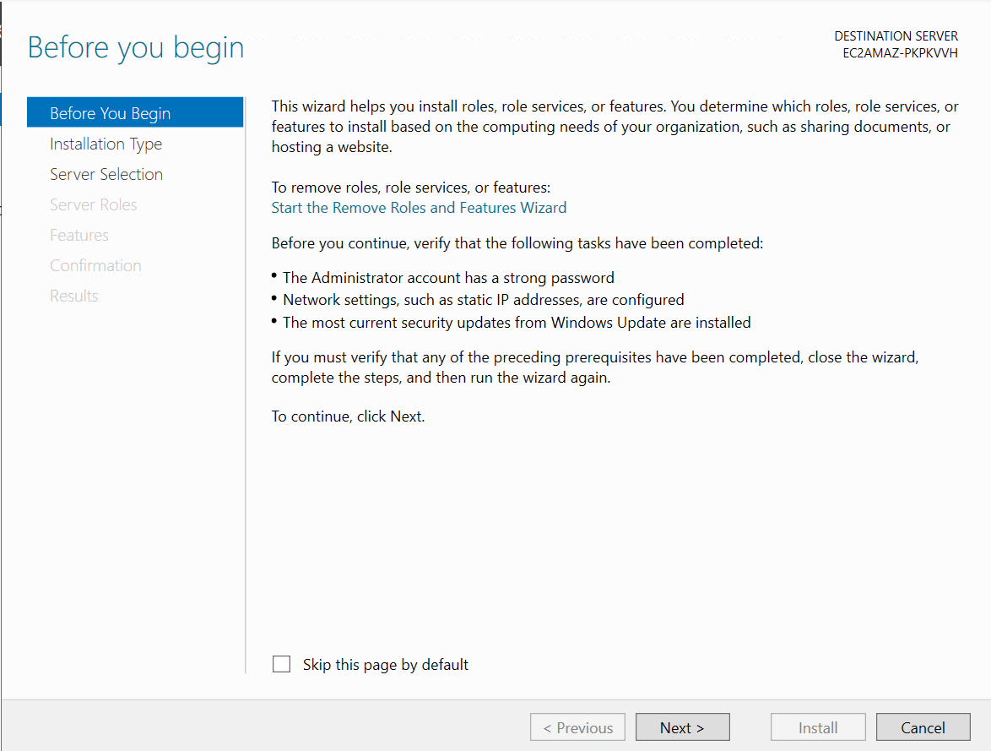

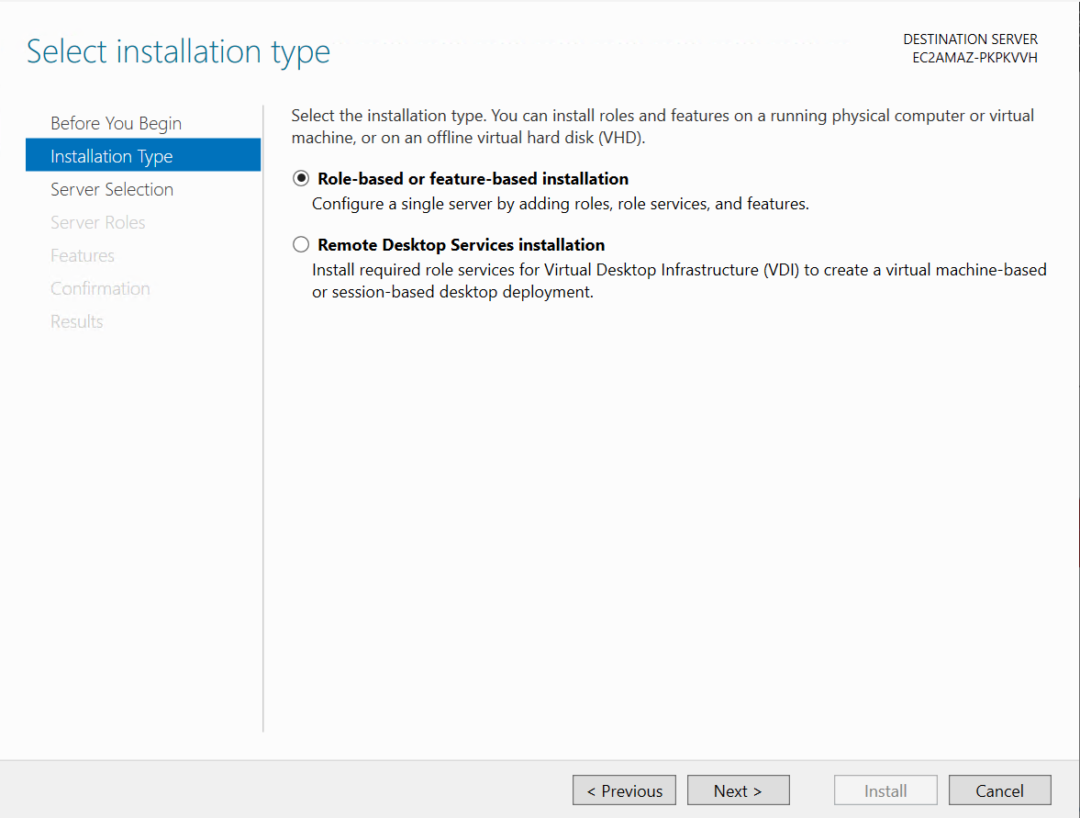

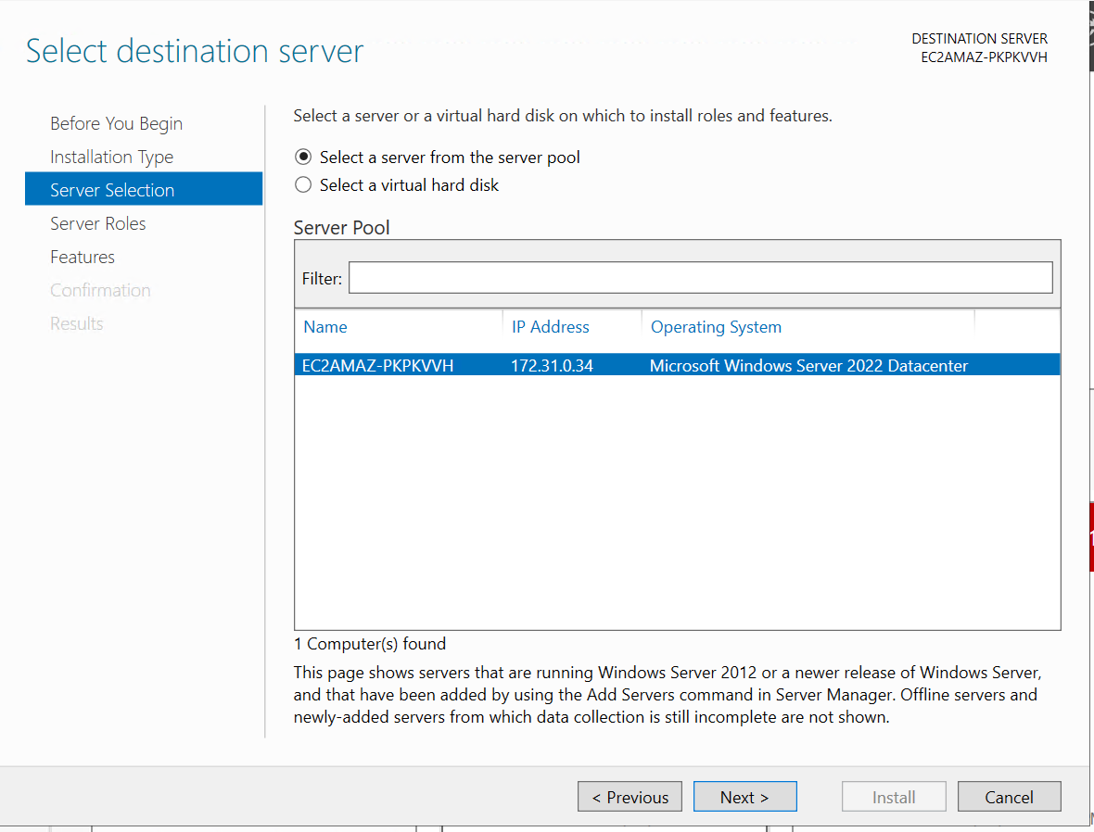

In the Add Roles and Features Wizard, Server Roles page, find and check “Web Server (IIS)”

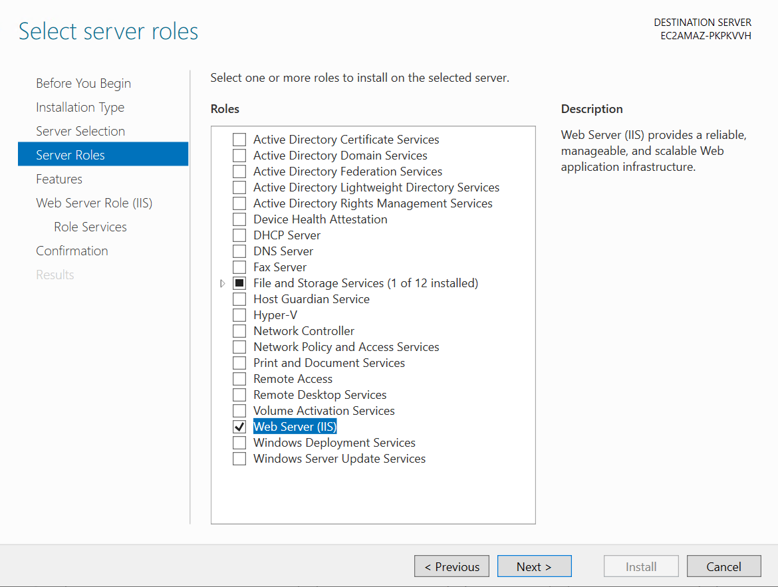

In the Roles Services for Web Server Role (IIS), check the desired options to be include in the installation

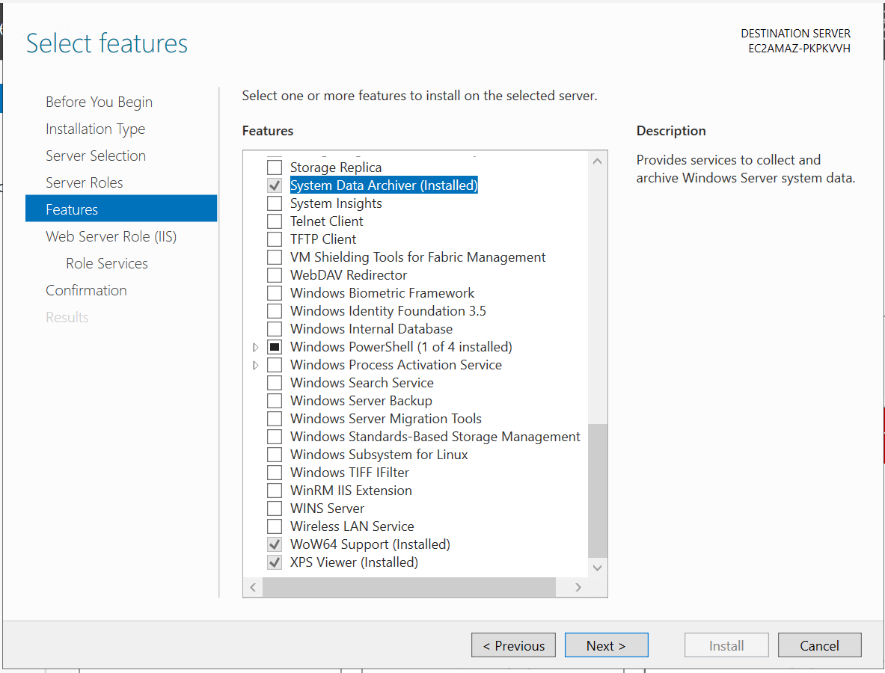

Confirm the installation

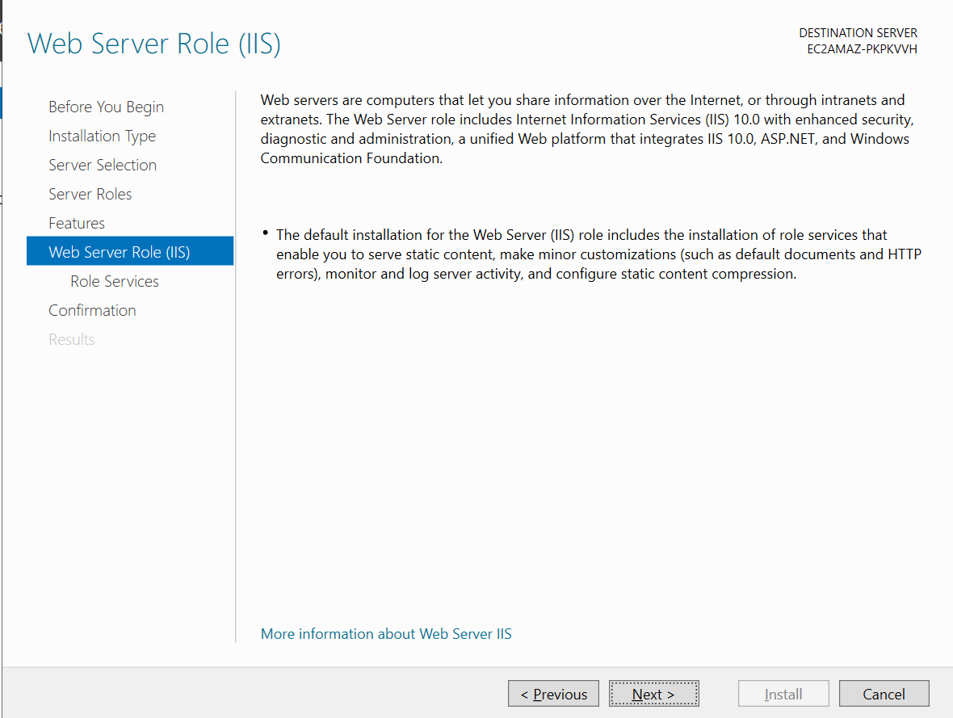

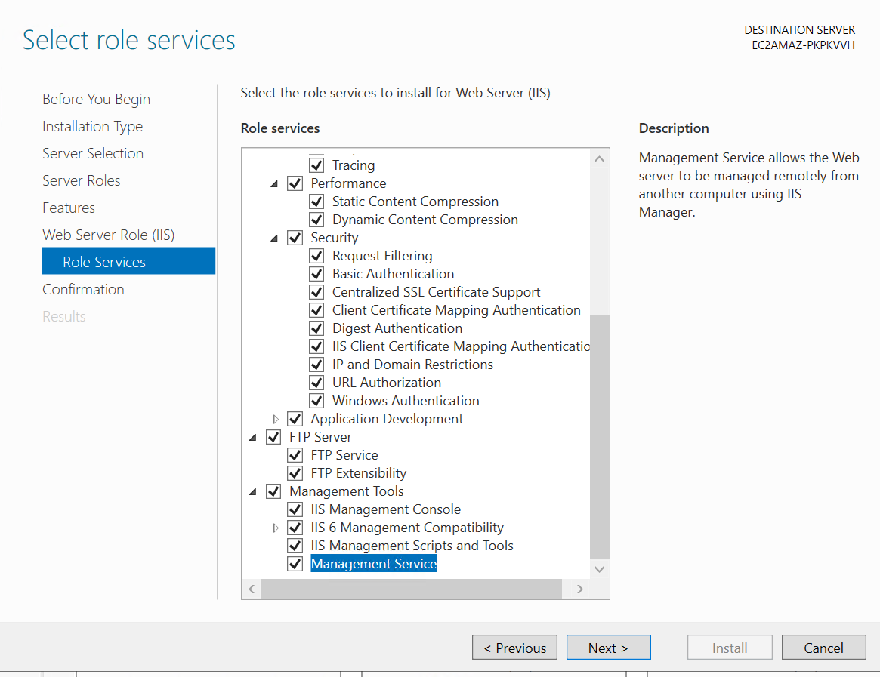

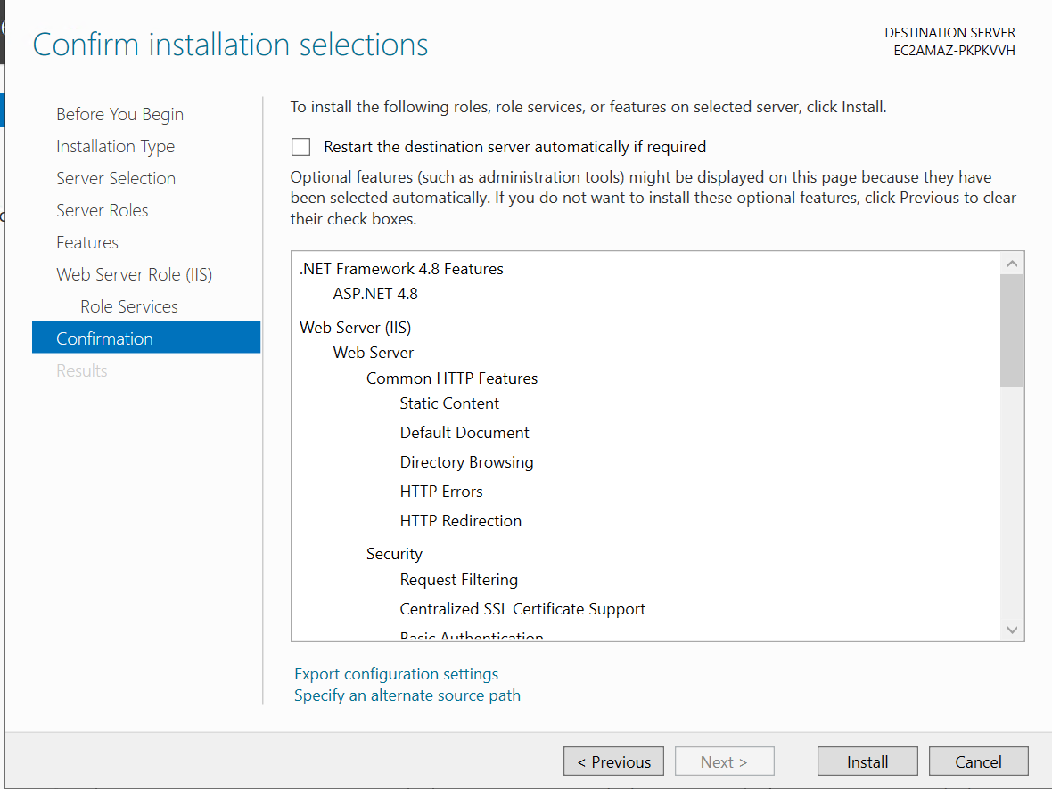

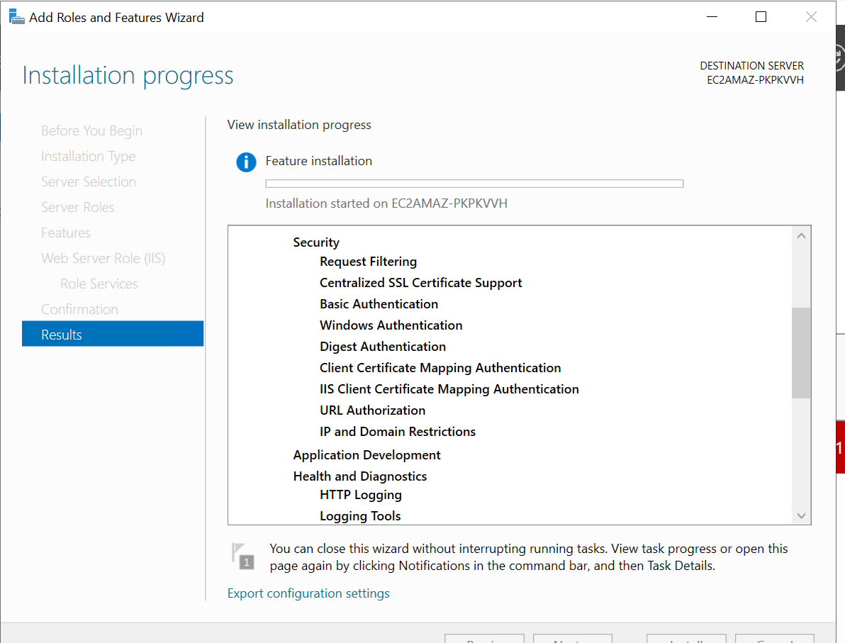

If everything is installed correctly, you should be able to enter the Public IP address of your EC2 instance in any web browser, and see the IIS default page.

